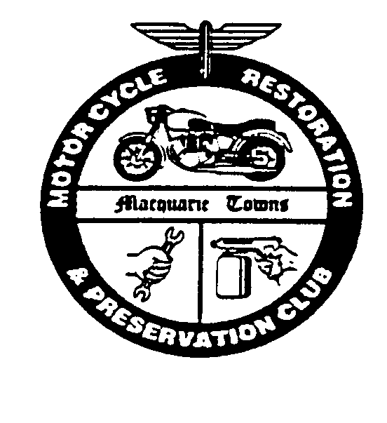
Macquarie Towns Motorcycle Restoration and Preservation Club
ANNUAL RALLY 30th/31st July 2022
Rally starts at: PITT TOWN SPORTS CLUB, 139 Old Pitt Town Rd, Pitt Town 2756
Join us for a meander through our beautiful Upper Hawkesbury district

PLEASE USE BLOCK LETTERS FOR ALL ENTRIES ON THIS DOCUMENT.
Check-In: 8.00am Ride Commences: 9.30am sharp Entries Close: Last mail 15 July 2022
Entrant
Details
Age box optional, prize for oldest bike/rider

Please complete a separate form for each rider.

Machine Entered

Entry Fees
All riders, pillions and marshals need to complete for catering

COVID - 19
Entrance to Pitt Town Sports Club requires proof of double vaccination.

Entrant's Name: Age in years? | Pillion / Partner Attending: YES or NO
 | Pillion / Partner Name:
Your Address:
 | Postcode:
Phone:  Mobile: | Email:
Club: | Non-riding Marshal/Official?
Make: | Year: Model:
Capacity: | Rego:
Entry Fee (includes 1 X T-shirt) | Cost Each | Number | Total Cost
Size: (S, M, L, XL, XXL, XXXL) | $25 |  | $
Saturday Morning Tea | $8 |  | $
Saturday Lunch | $15 |  | $
Saturday Dinner | $36 |  | $
Sunday Breakfast | $5 |  | $
Late Entry (no T-Shirt)
Raffle Tickets: 12 for $5 or 30 for $10 | No of tickets |  | $
 |  | Total Cost … | $
Cheques should be made payable to MTMRPC and returned with completed and signed entry form to: The Rally Registrar. PO BOX 4254 PITT TOWN NSW 2756
OR: Direct Deposit: (Please advise receipt number for confirmation)
Account Name: Macquarie Towns Rally BSB: 112 879 (St George)
Account Number: 4569 63577
Enquiries: mactownsrally@gmail.com Garry Appleyard 0417 335 711
Steve Runnalls 0418 222 348
INDEMNITY STATEMENT: I undertake not to hold Macquarie Towns Motorcycle Restoration and Preservation Club or any of its representatives or sponsors responsible for any damage or theft of machinery or possessions or any bodily injury sustained during the course of the rally.
I also declare that I am the holder of a current motorcycle licence and that the motorcycle I will be riding in the rally will be RTA registered or club-plate registered. I understand that the rally organisers reserve the right to prevent motorcycles not complying with the above from entering the rides.

Entrant’s Signature …………………………………………… Date ………………………………………

